Supplementary figures

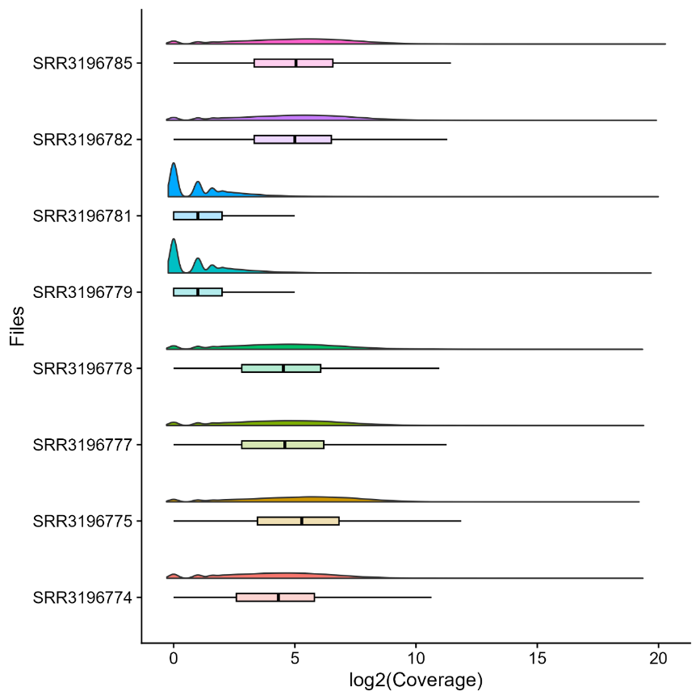

**Supplementary Figure 1.** **Log2(Coverage) of intergenic regions depicted as violin and box plot for each sample in PRJNA313774 dataset.**

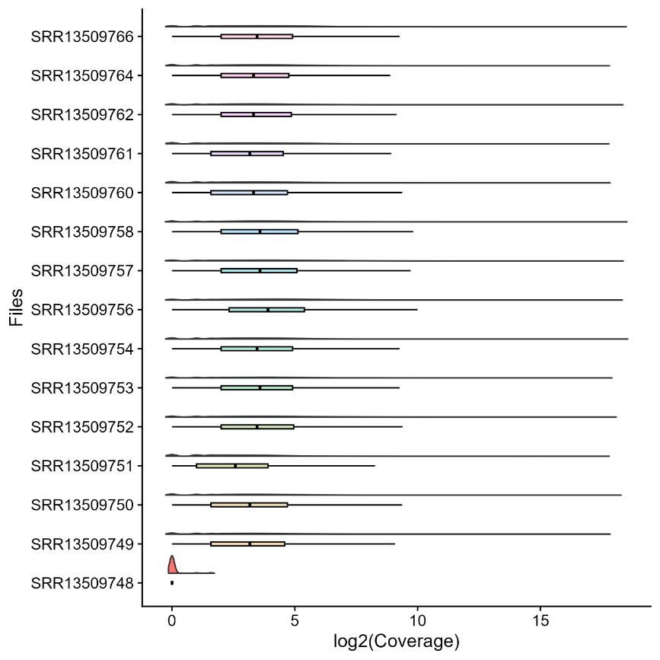

**Supplementary Figure 2.** **Log2(Coverage) of intergenic regions depicted as violin and box plot for each sample in PRJNA694147 dataset.**

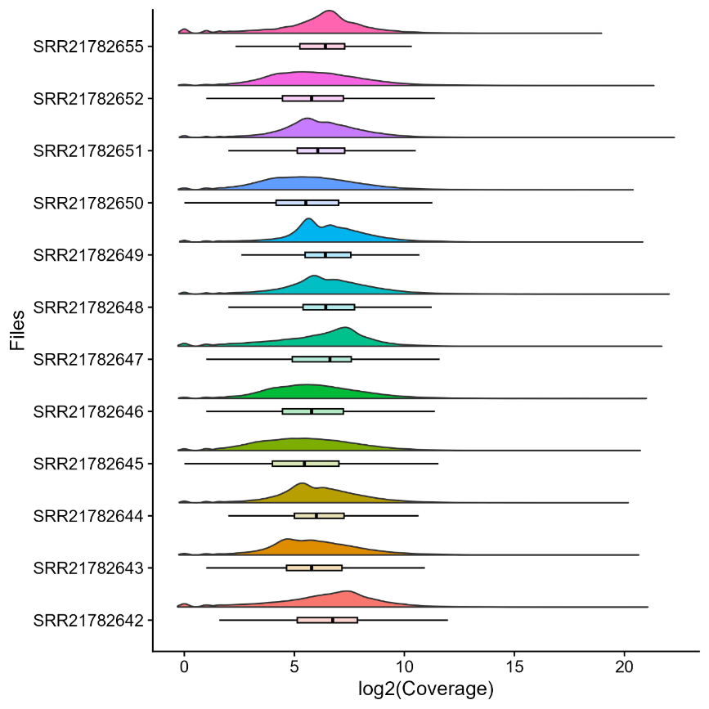

**Supplementary Figure 3. Log2(Coverage) of intergenic regions depicted as violin and box plot for each sample in PRJNA886436 dataset.**

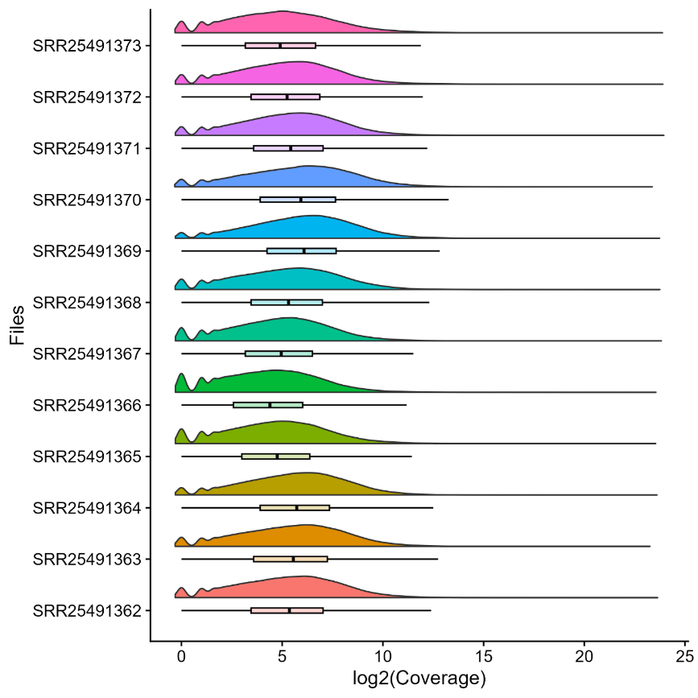

**Supplementary Figure 4. Log2(Coverage) of intergenic regions depicted as violin and box plot for each sample in PRJNA1001307 dataset.**

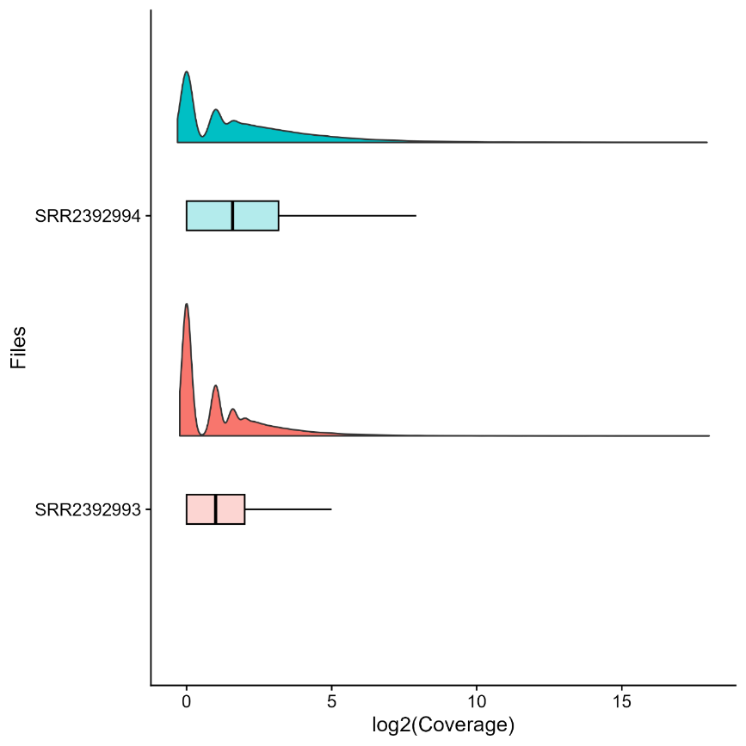

**Supplementary Figure 5.** **Log2(Coverage) of intergenic regions depicted as violin and box plot for each sample in PRJNA295556 dataset.**

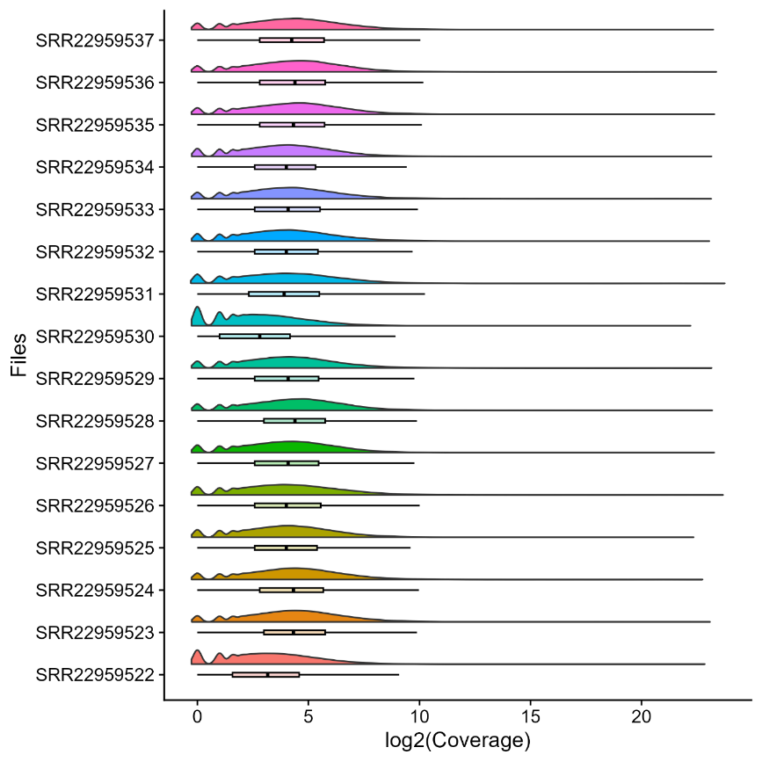

**Supplementary Figure 6. Log2(Coverage) of intergenic regions depicted as violin and box plot for each sample in PRJNA917642 dataset.**

|  |
| --- |
| **Supplementary Figure 7. Raw count data compared toDeseq2 normalised count data prior to further transformations for all datasets.** |

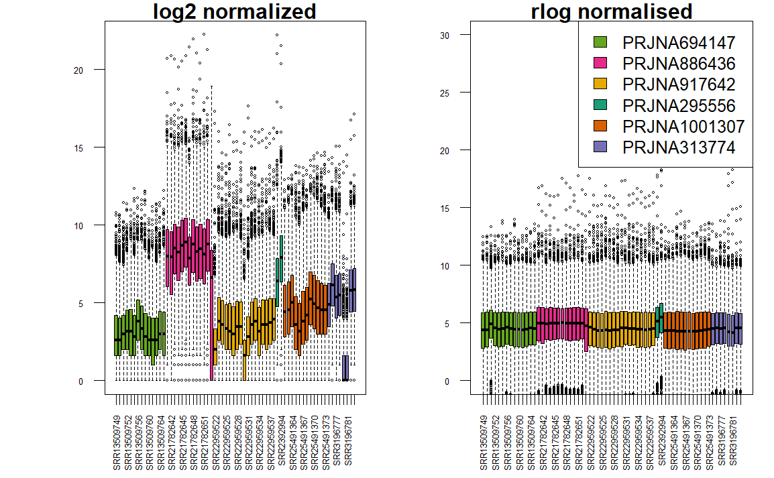

|  |
| --- |
| **Supplementary Figure 8. Log2 vs rlog transformed count data for all datasets.** |

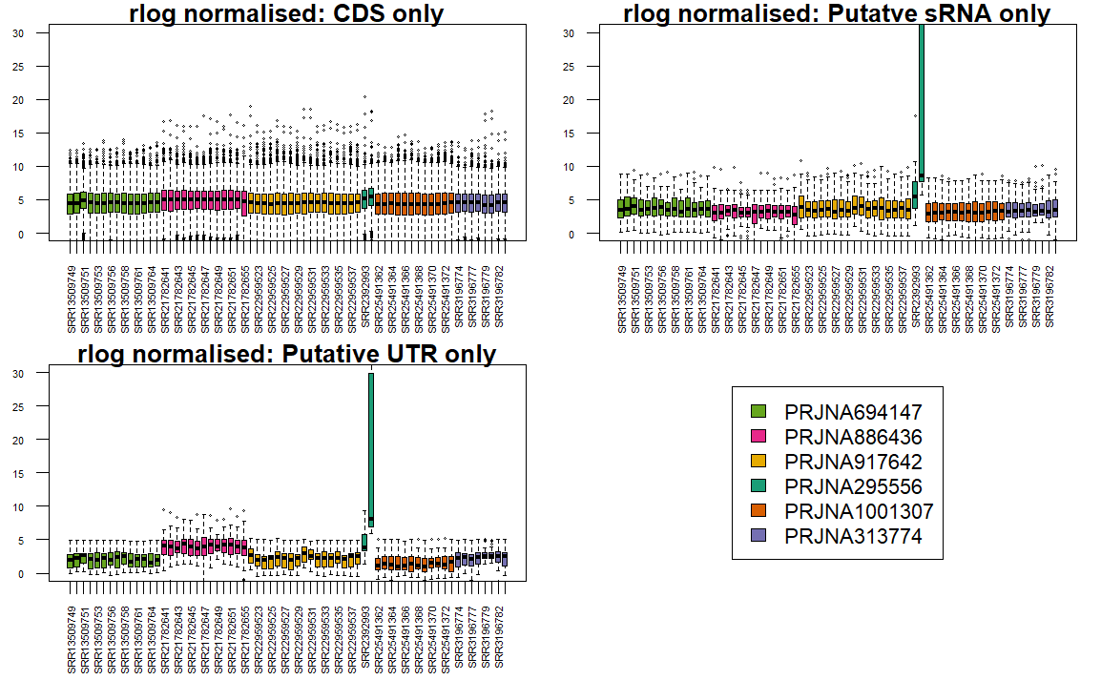

**Supplementary Figure 9. Rlog normalised count data for Coding regions, putative sRNAs and putative UTRs.**

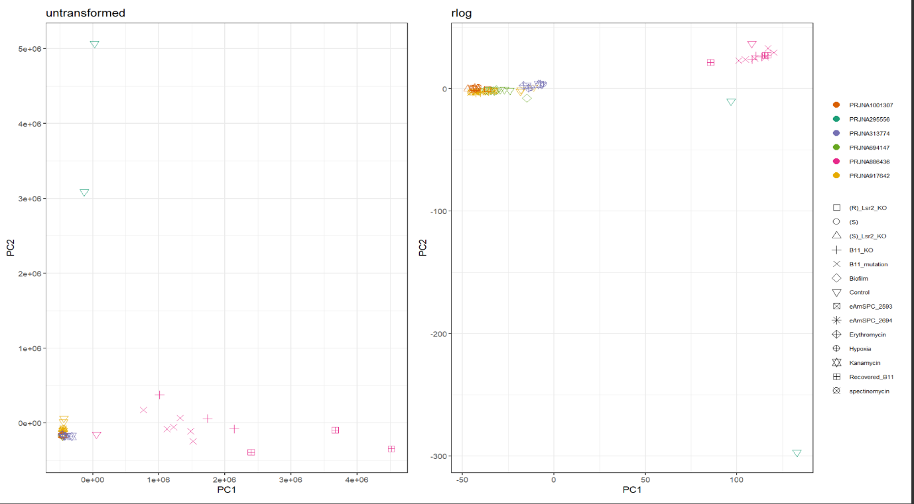

**Supplementary Figure 10. PCA plot of raw read counts and following normalisation and transformation.**

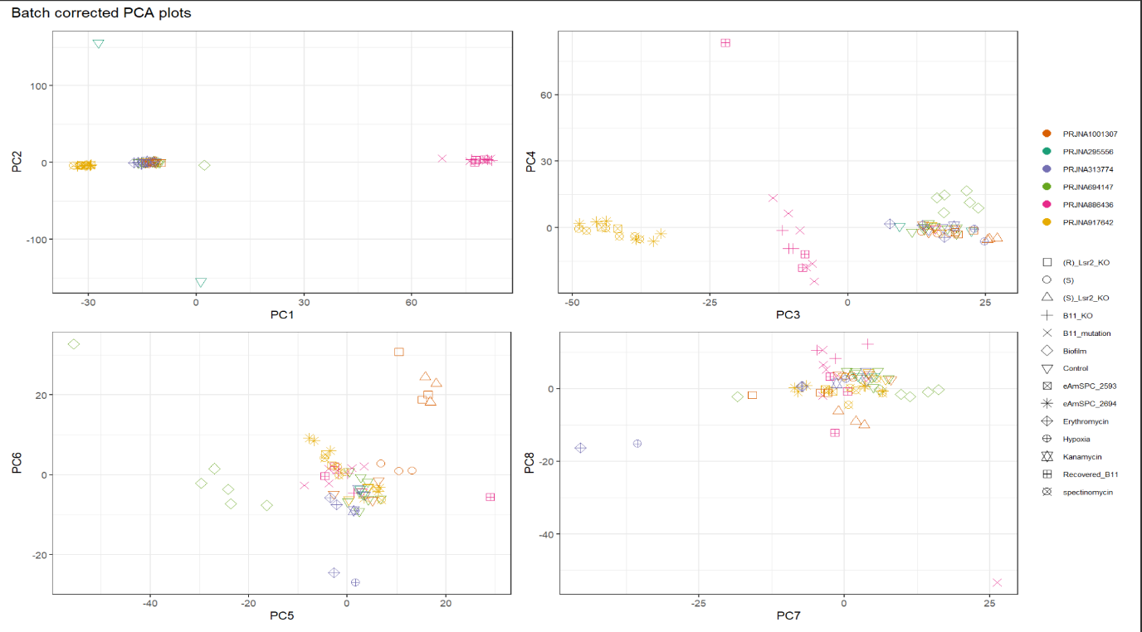

**Supplementary Figure 11. PCA plots for batch corrected read counts depicting datasets by colour and conditions by shape.**

|  |
| --- |
| **A)** |
| **B)** |
| **Supplementary Figure 12. Dendrogram depicting the relationship all samples in paired end datasets.** A) Relationship between samples prior to batch correction. B) Relationship between samples following batch correction. |
| **A)** |
| **B)** |
| **Supplementary Figure 13. Dendrogram depicting the relationship between all samples in single end datasets.**  A) Relationship between samples prior to batch correction. B) Relationship between samples following batch correction. |

|  |  |
| --- | --- |
| **A)** | **B)** |
| **C)** | **D)** |
| **E)** | |
| **Supplementary Figure 14. PCA plot of each dataset depicting the PC1 and PC2 distribution of samples in each dataset.** **A)** Dataset PRJNA694147. **B)** Dataset PRJNA886436. **C)** Dataset PRJNA917642. **D)** Dataset PRJNA295556. **E)** Dataset PRJNA313774. | |

|  |  |
| --- | --- |
| **A)** | **B)** |
| **C)** | |
| **Supplementary Figure 15.** **Volcano plot of differential expression in PRJNA313774 dataset. A)** Differentially expressed features in Kanamycin treated samples. **B)** Differentially expressed features in Erythromycin treated samples. **C)** Differentially expressed features in samples under hypoxic conditions. | |

**Supplementary Figure 16. Volcano plot of differentially expressed features in planktonic vs biofilm samples from dataset PRJNA694147.**

|  |  |
| --- | --- |
| **A)** | **B)** |
| **C)** | |
| **Supplementary Figure 17.** **Volcano plot of differential expression in PRJNA886436 dataset. A**) Differentially expressed features in B11 knockout samples. **B)** Differentially expressed features in samples containing a B11 mutation. **C)** Differentially expressed features in samples where B11 was knocked out and then recovered. | |
|  | |

|  |  |
| --- | --- |
|  | |
|  |  |
| **Supplementary Figure 18.** **Volcano plot of differential expression in PRJNA917642 dataset. A)** Differentially expressed features in Lsr2 spectinomycin treated samples. **B)** Differentially expressed features in spectinomycin derivative drug (eAmSPC_2694) treated samples. **C)** Differentially expressed features in spectinomycin derivative drug (eAmSPC_2593) treated samples. | |